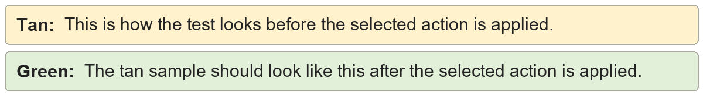
Non-breaking spaces | Alpha Bravo Charlie
Non-breaking spaces | Alpha Bravo Charlie

Zero-width spaces | zero​width​characters
Zero-width spaces | zerowidthcharacters

Zero-width non-joiners | non‌joiner
Zero-width non-joiners | nonjoiner

Zero-width joiners | joined‍word
Zero-width joiners | joinedword

Byte order marks | hidden﻿mark
Byte order marks | hiddenmark

Soft hyphens | soft­hyphen
Soft hyphens | soft-hyphen

Non-breaking hyphens | non‑breaking‑hyphen
Non-breaking hyphens | non-breaking-hyphen

